Question 32 (13 marks)

1. Write a suitable hypothesis for this experiment. (1 mark)

Hypothesis must state how independent variable affects dependent variable (increase/decrease/no effect)

***e.g. Levothyroxine reduces average blood cholesterol/LDL levels.***

1. State two variables that would need to be controlled that are not mentioned.(2 marks)

Any two

* + **Age of subjects same**
  + **Gender of subjects same**
  + **Amount/dose of drug/placebo needs to be the same**
  + **Diet would need to be the same**
  + **Exercise levels would need to be the same**

1. A medication provided to the control group in an experiment that is identical in every way, except that it contains no active ingredient. Provides an equal psychological effect between the control and experimental groups.
2. Plot a graph of the information contained in the table. (5 marks)

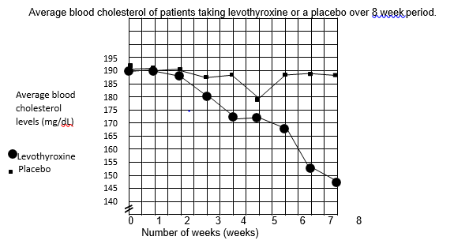

Bar graph – maximum three points

* **Points plotted correctly and joined to form a line**
* **Title must include independent and dependent**
* **X and Y axis labelled correctly, including units**
* **Axes constructed using appropriate scale (at least half the grid)**
* **Each line labelled/shown in a legend/key**

1. What conclusion can be drawn from the results? (2 marks)

E.g.

levothyroxine lowers cholesterol/LDL levels (in people who suffer hypothyroidism) (1) whereas the placebo appeared to have little effect on the level of LDLs/cholesterol (1)

f) (2 marks)

Increase the sample size/more subjects (1) Repeat the trials (1)